Lab Exercise 19- Launching the Kubernetes Dashboard

Steps to be followed:
- Implement the dashboard deployment
- Validate the pod, service, and deployment creation
- Confirm the dashboard service type
- Access the master node IP
- Log in to the service dashboard
- Access the Kubernetes dashboard

Step 1: Implement the dashboard deployment

  - Run the following command to deploy the dashboard user interface:
kubectl apply -f https://raw.githubusercontent.com/kubernetes/dashboard/v2.7.0/aio/deploy/recommended.yaml

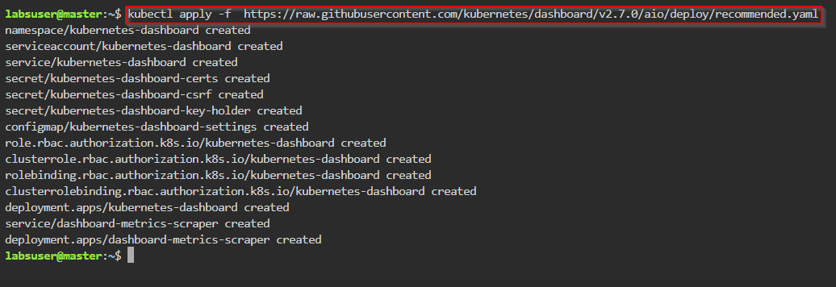

Step 2: Validate the pod, service, and deployment creation

- Enter the following commands to verify if the pods, services, and deployments have been created:
kubectl get pods -n kubernetes-dashboard -o wide
kubectl get deployment -n kubernetes-dashboard -o wide
kubectl get svc -n kubernetes-dashboard -o wide

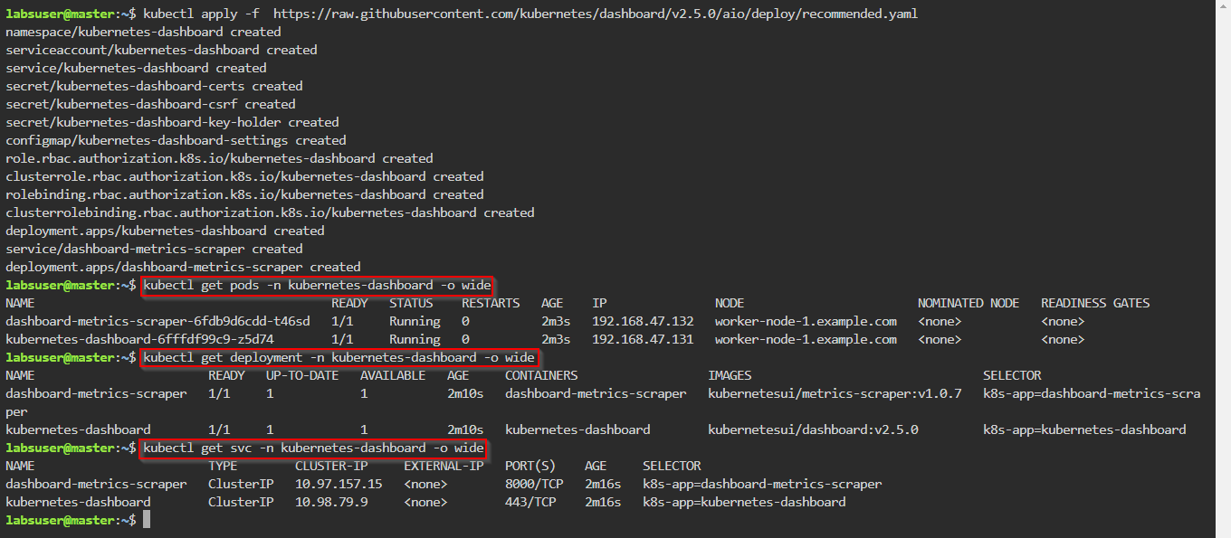

- Run the following command to access the service outside the cluster and edit the service type from ClusterIP to NodePort:
kubectl edit svc -n kubernetes-dashboard kubernetes-dashboard

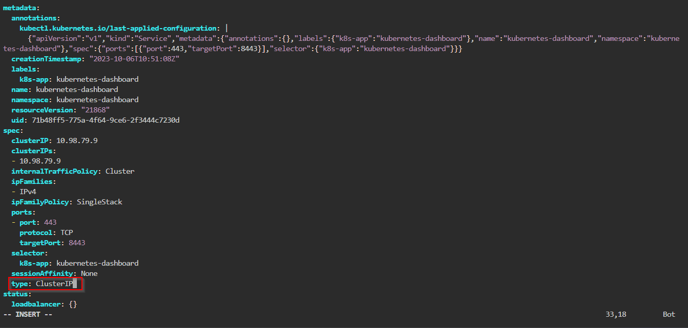

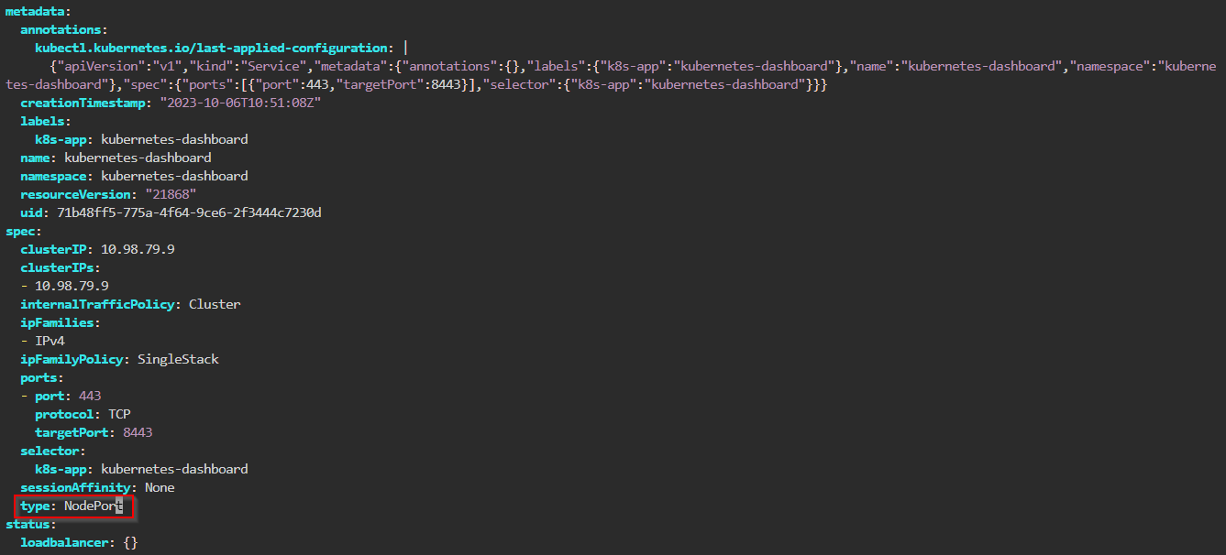

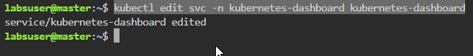

Step 3: Confirm the dashboard service type

- Run the following command to confirm that the service type has been changed to NodePort:
kubectl get svc -n kubernetes-dashboard -o wide

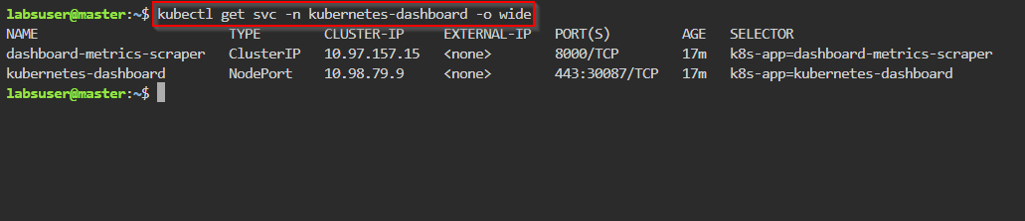

- Run the following commands to determine the location of the pod:
kubectl get pods -n kubernetes-dashboard -o wide
kubectl get svc -n kubernetes-dashboard -o wide
kubectl get nodes -o wide

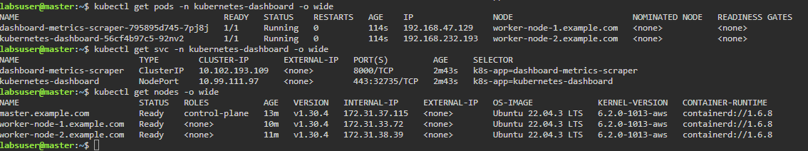

Note: In this case, the pod is running on worker-node1. Note down the IP and NodePort of node1.

- Use the INTERNAL-IP as 172.31.33.72 and PORT(S) as 32735 and copy the link: https:// 172.31.33.72:32735



Note: In your case, the IP and NodePort will be different. Change the IP and NodePort accordingly:
https:// <<your worker-node-1>>:<<NodePort>>

Step 4: Access the master node IP

- Open Firefox, paste the copied link from step 3.3 in to the search bar, and press Enter

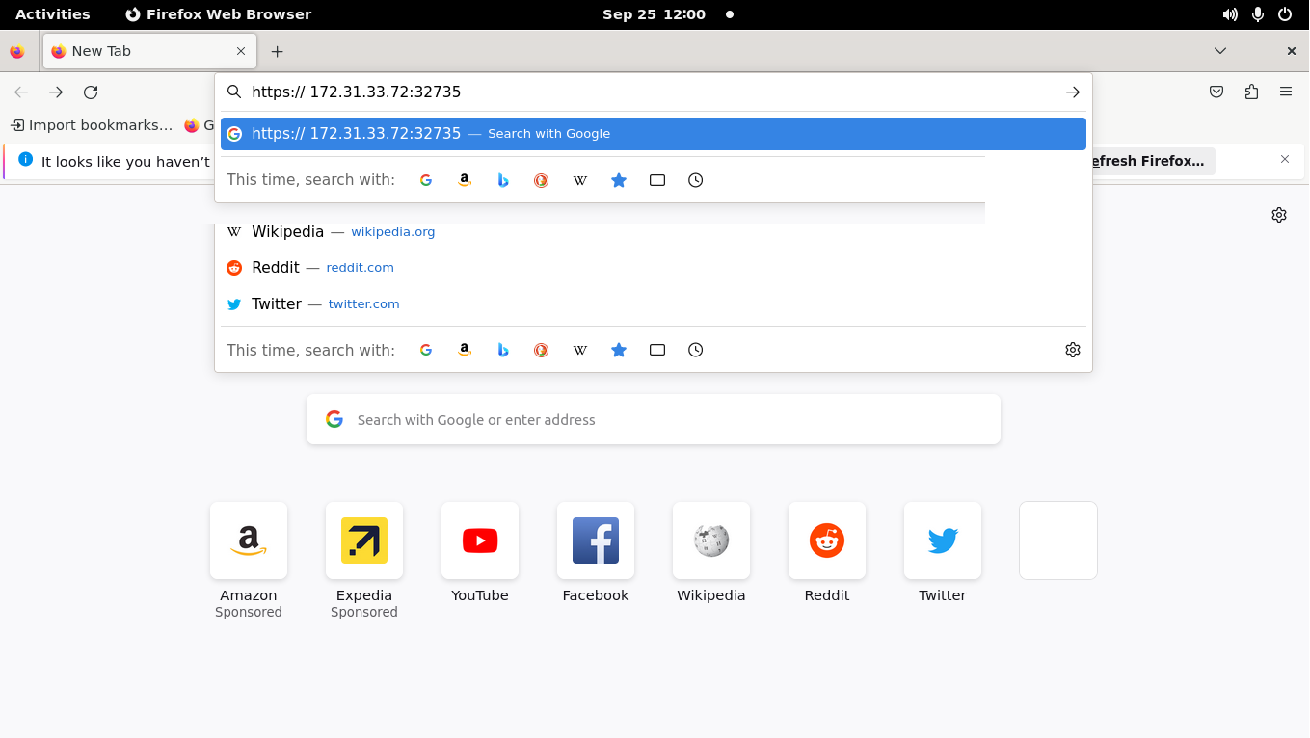

- Click on the Advanced button

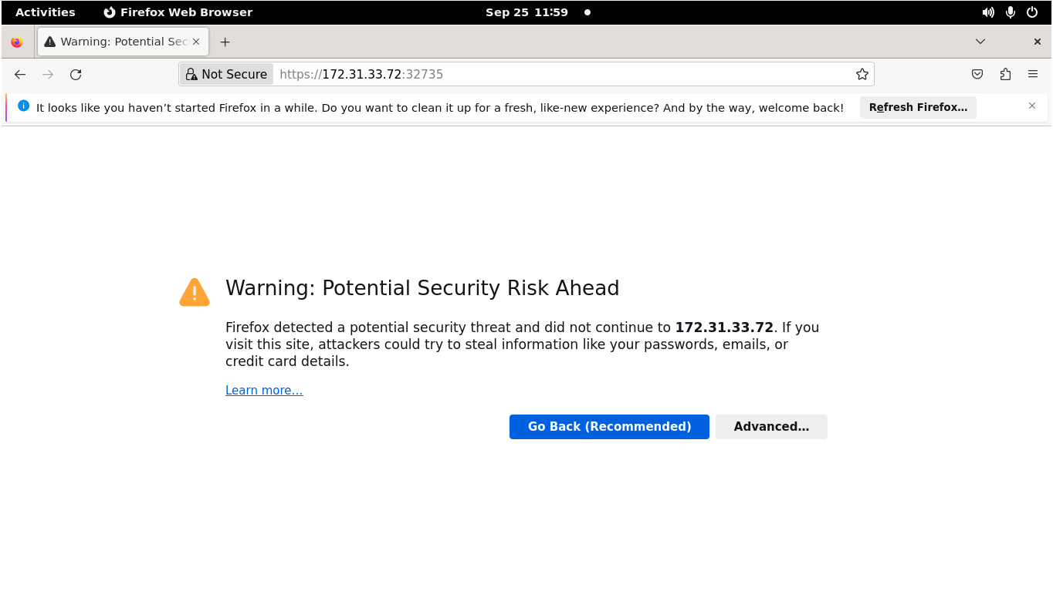

- Click on Accept the Risk and Continue

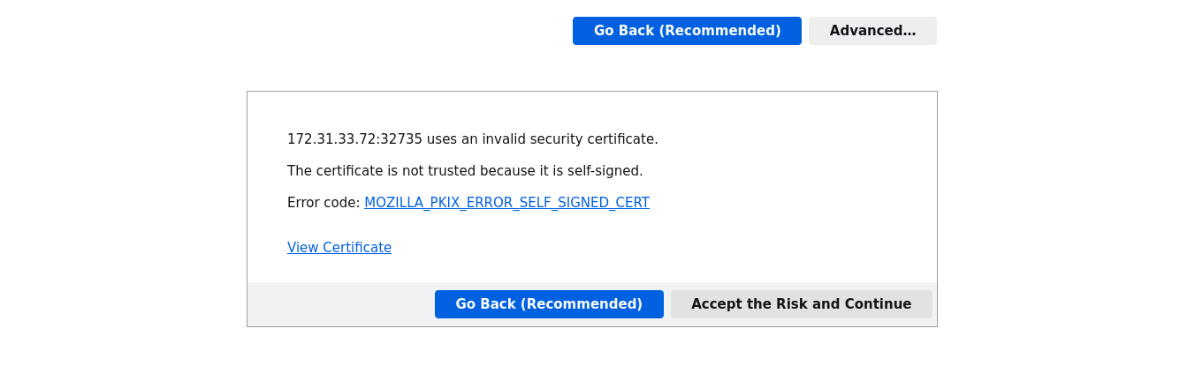

Step 5: Log in to the service dashboard

- Create a service account by running the following command and then input the code in the master node:
ServiceAccount.yaml

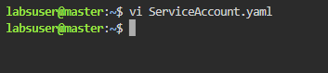

apiVersion: v1
kind: ServiceAccount
metadata:
name: admin-user
namespace: kubernetes-dashboard

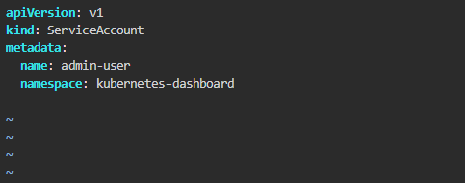

- Apply the YAML file with the command:
kubectl apply -f ServiceAccount.yaml

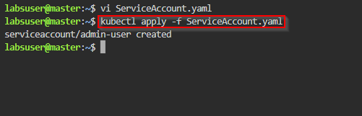

- Create a yaml file for cluster role binding using the below command and code:
ClusterRoleBinding.yaml

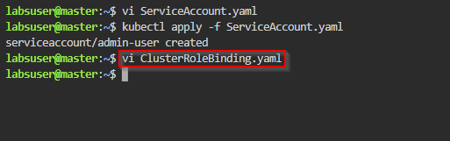

apiVersion: rbac.authorization.k8s.io/v1
kind: ClusterRoleBinding
metadata:
name: admin-user
roleRef:
apiGroup: rbac.authorization.k8s.io
kind: ClusterRole
name: cluster-admin
subjects:
- kind: ServiceAccount
name: admin-user
namespace: kubernetes-dashboard

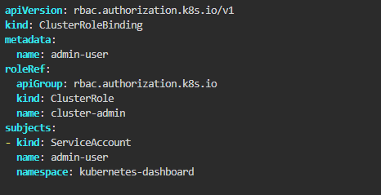

- Run the following command to create cluster role binding:
kubectl apply -f ClusterRoleBinding.yaml

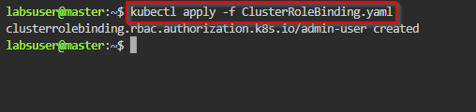

- Retrieve the token to log in by running the following command:
kubectl -n kubernetes-dashboard create token admin-user

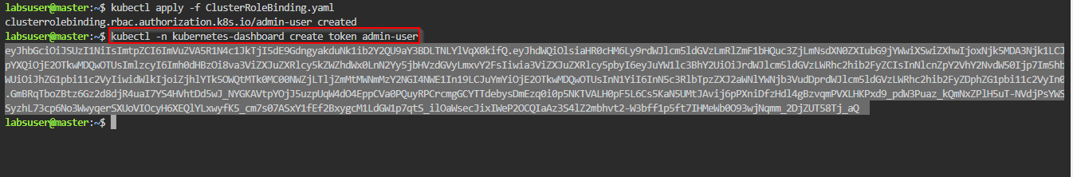

- Copy the token and paste it in to the Kubernetes dashboard log in screen and then click on Sign in

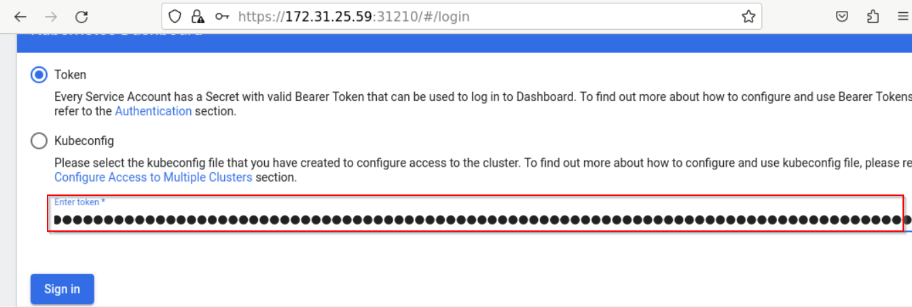

Step 6: Access the Kubernetes dashboard

- Click on the All namespaces drop-down menu

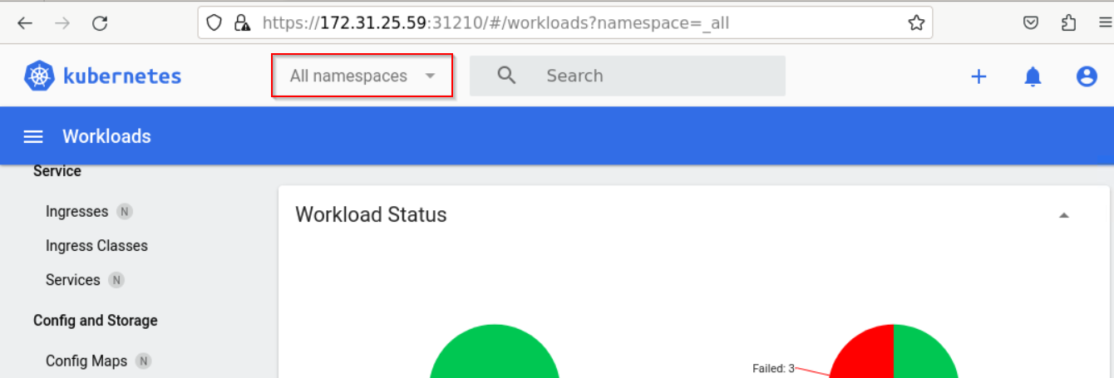

- Select kube-system

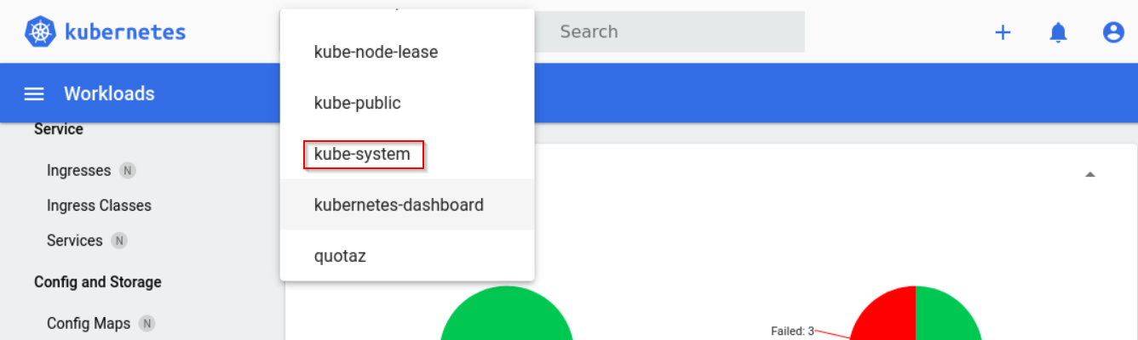

- Use the search bar to find and select kube-apiserver

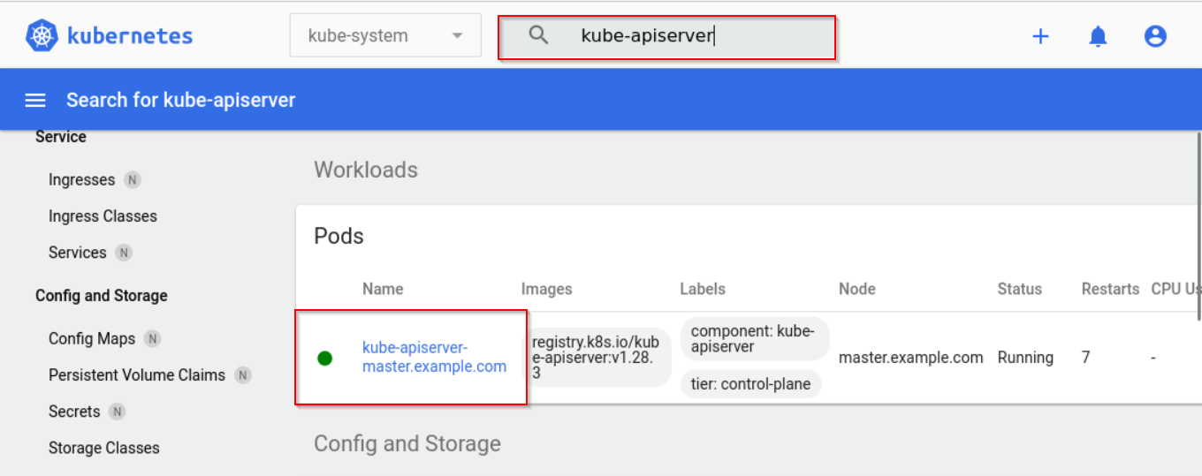

View the logs of the kube-apiserver

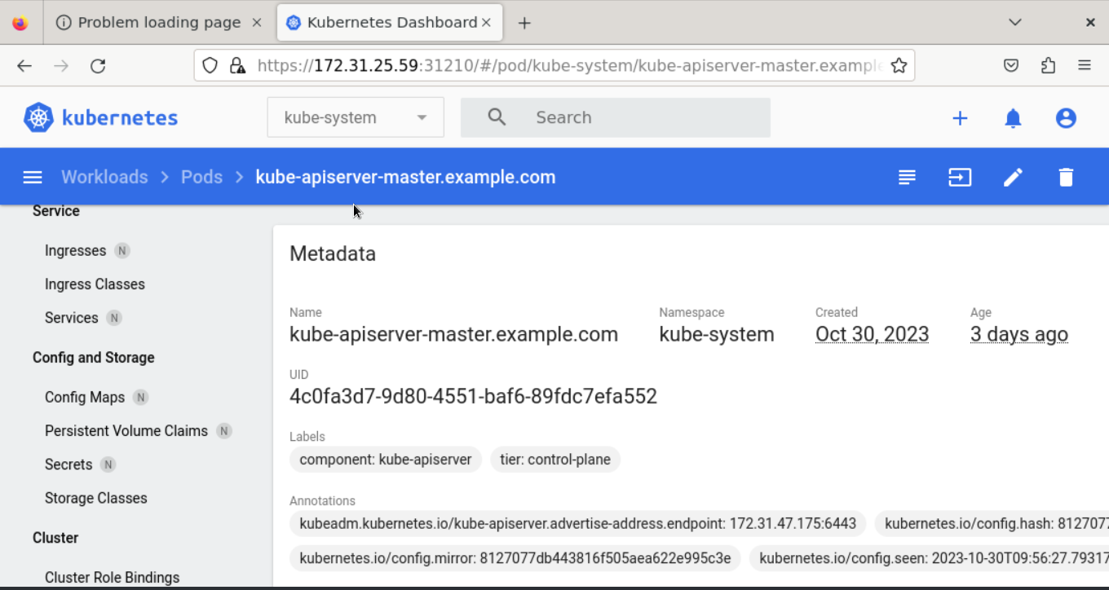

- [OPTIONAL] Cleanup: To delete the Kubernetes dashboard version 2.5, use the following command in the master node:
kubectl delete -f https://raw.githubusercontent.com/kubernetes/dashboard/v2.5.0/aio/deploy/recommended.yaml

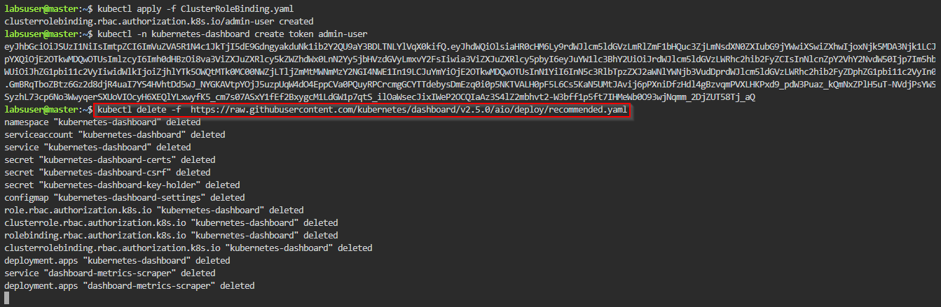

By following these steps, you will be able to deploy the Kubernetes Dashboard, establish secure access, and navigate the interface to monitor and manage your Kubernetes cluster.

